Let the Culture Speak
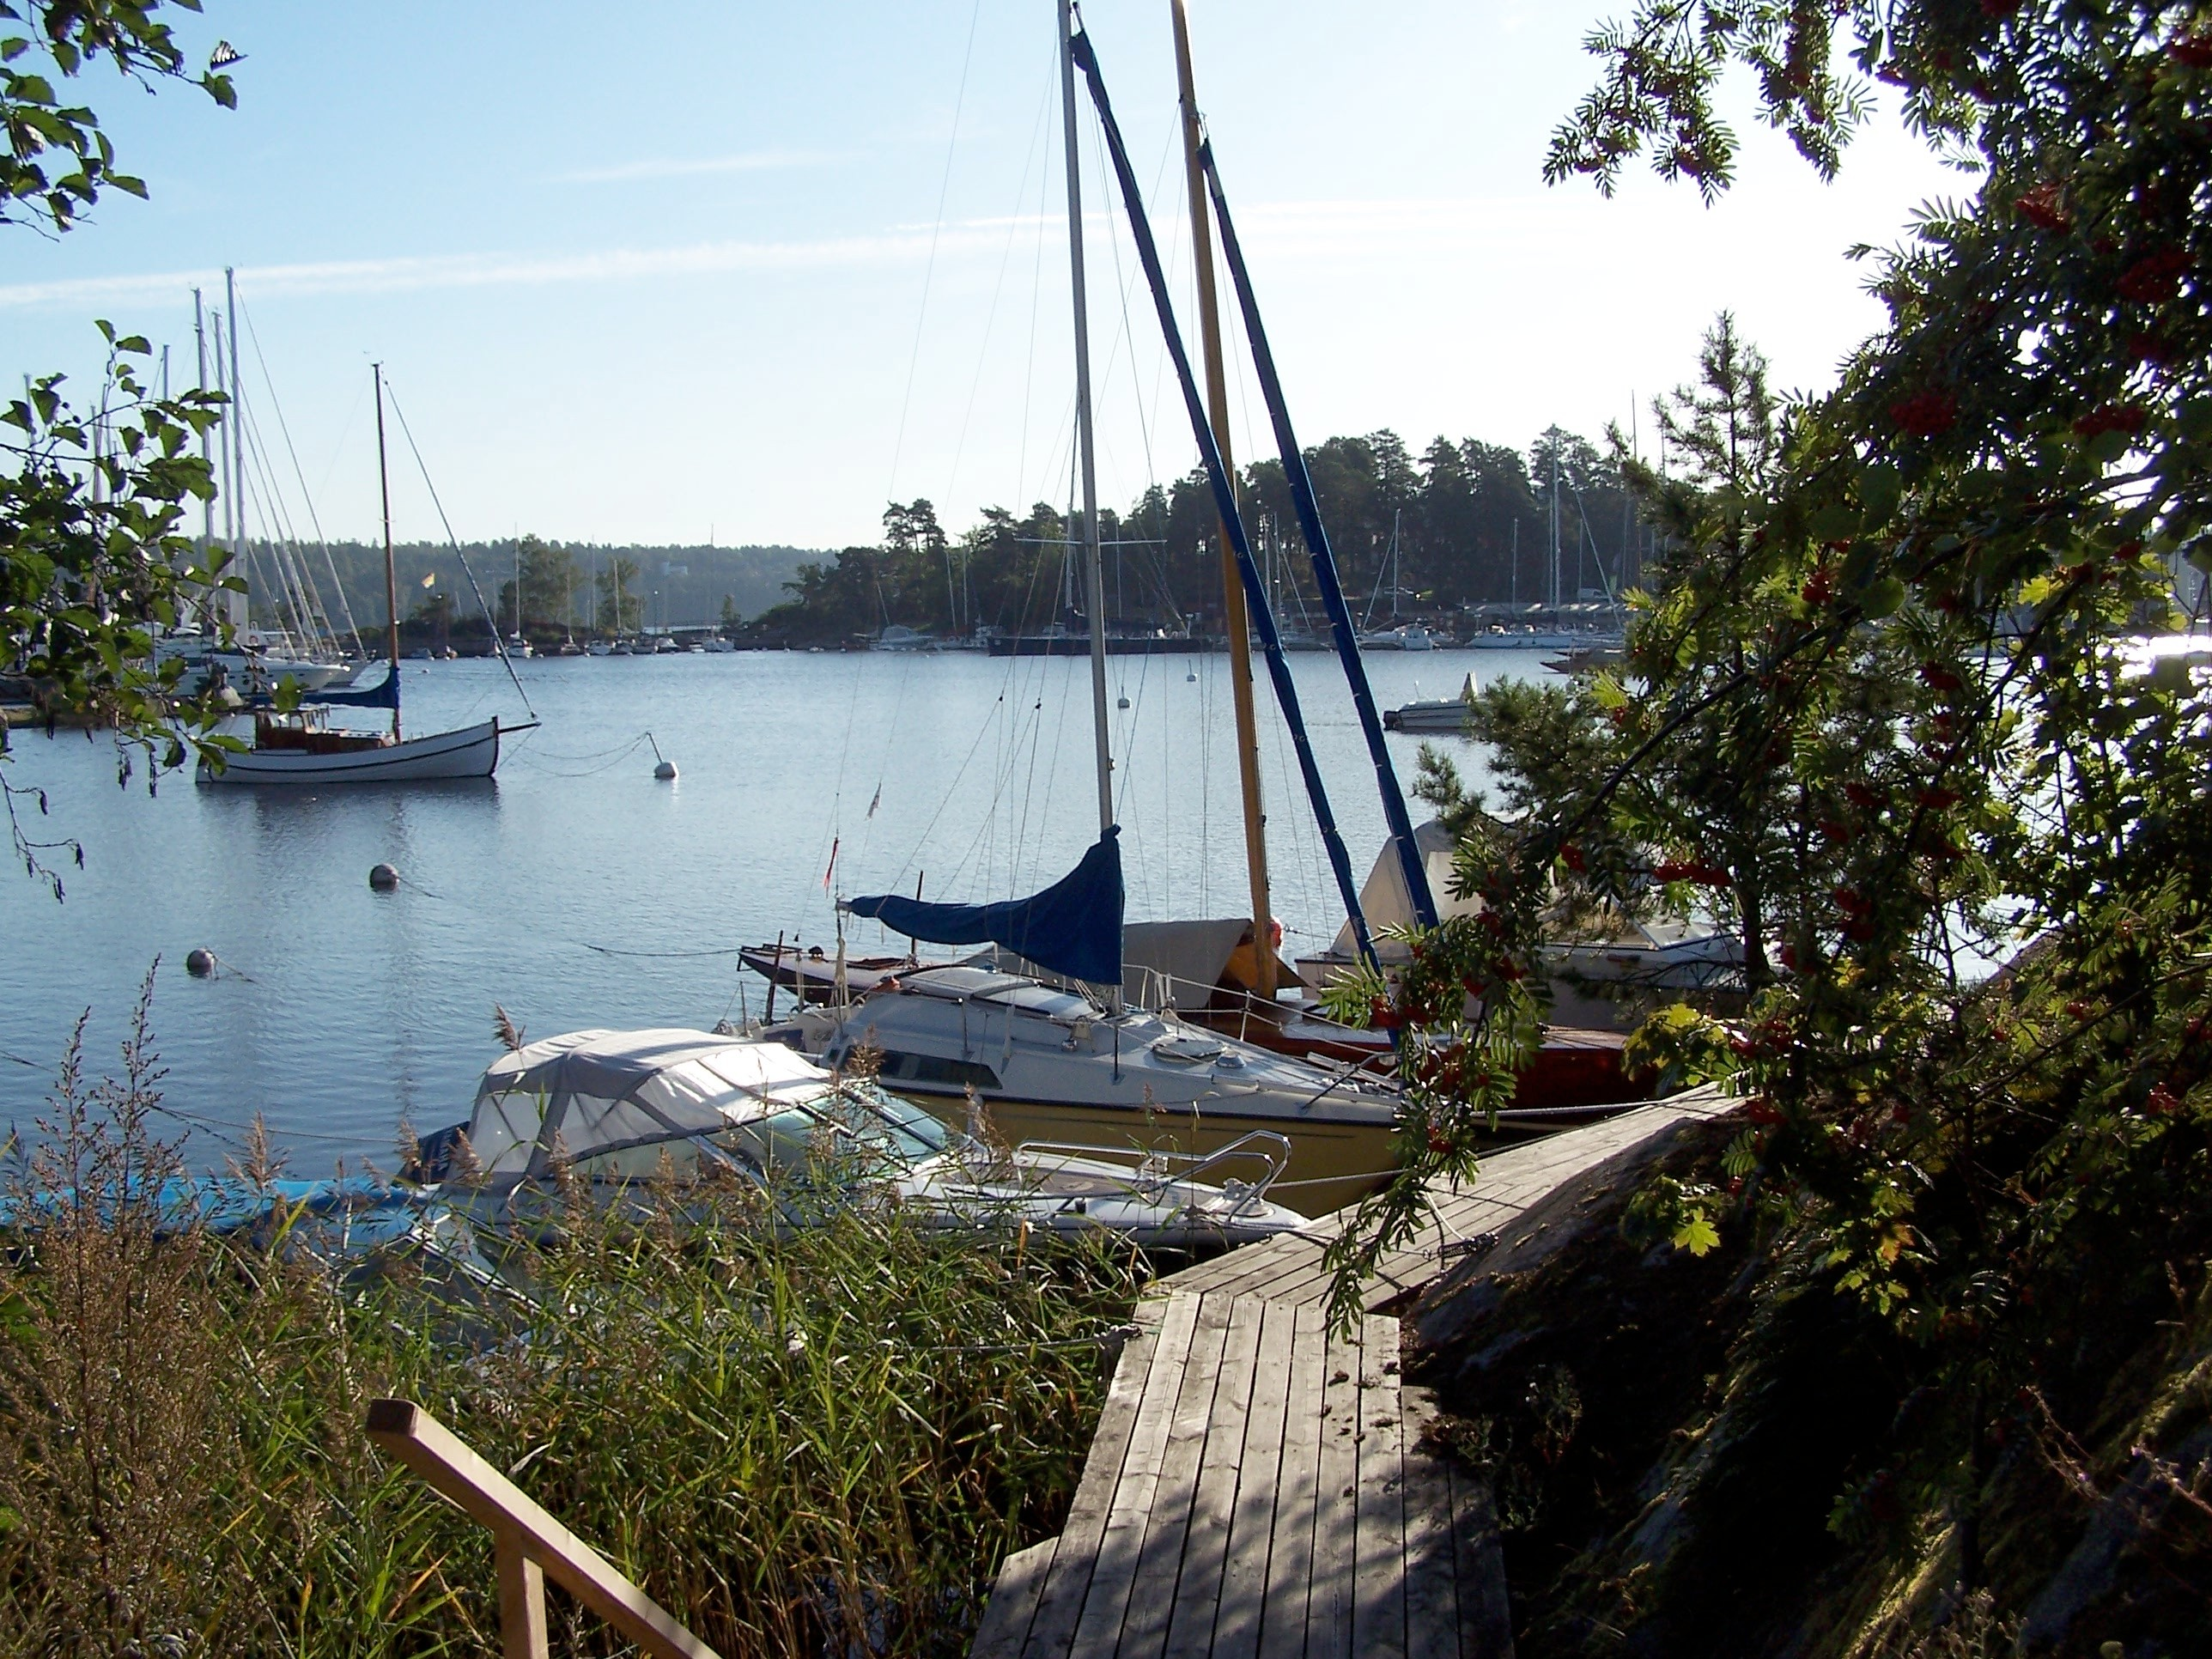
… is an open forum for anybody who would like to speak and listen with others. It is a unique possibility to become more of the person you wish to be and to improve your understanding of the forces that influence your life.

Our work in the group rests on an established method that has existed since 1996. Our facilitator is one of the most experienced median group conductors in Europe,
Teresa von Sommaruga Howard.

Group membership is multicultural and multi-professional so there are lots of possibilities to learn. We work in an accepting atmosphere, in peaceful surroundings. We have learnt that learning can be pleasant too!

If you are interested in
- Contributing to cultivating a more humane society
- Finding a place where you can make yourself heard
- Finding meaning for difficult life situations
- Improving your leadership skills

Let the Culture Speak might be for you!

How and where could I apply my learning?
Participation in the work of the group may well improve your capacity to mediate and conciliate in situations of conflict. You may become a more effective manager of yourself and others.

How often do we meet?
Four times a year: winter, spring, summer and autumn on
Fridays: 17:30 to 21:00 and Saturdays: 09:00 to 13:00.
For dates visit www.LettheCultureSpeak.eu

How committed do you have to be?
This learning process takes time. It demands a commitment of at least a year but it is the only way we know of. It is not a ‘quick fix’ but it may well assist you in building an integrated competence that will enable you to ‘actually’ live your life.

What does it cost?
For attending a full weekend meeting, including a light meal on Friday evening and Saturday morning:
New members for first year, students and retired people: 800:-­‐. Committed members after first year 1600:-­‐.

Further information and registration:
Visit www.lettheculturespeak.eu or email Teresa von Sommaruga Howard on: Teresa@JustDialogue.com

